  2007  TRIAL HIGHER SCHOOL CERTIFICATE EXAMINATION  Chemistry  Thursday 23 August, 9.00 – 12.00  General Instructions  - Reading time – 5 minutes  - Working time – 3 hours  - Write using black or blue pen  - Draw diagrams using pencil  - Board approved calculators may be used  - Write your student number at the top of every page.  Mr Weeding  Mr Hunter  43 students, 55 papers | Total marks – 100  Section I Pages 2 - 21  75 marks  This section has two parts, Part A and Part B  Part A – 15 marks  - Attempt Questions 1-15  - Allow about 30 minutes for this part  Part B – 60 marks  - Attempt Questions 16-28  - Allow about 1 hour and 45 minutes for this part  Section II Pages 22-24  25 marks  - Attempt Question 29  - Answer in a writing booklet. Extra booklets are available.  - Allow about 45 minutes for this section

Section I
75 marks

Part A – 15 marks
Attempt Questions 1-15
Allow about 30 minutes for this part

Use the multiple-choice answer sheet.

Select the alternative A,B,C or D that best answers the question. Fill in the response oval completely.

Sample: 2 + 4 = (A) 2 (B) 6 (C) 8 (D) 9

A B C D

If you think you have made a mistake, put a cross through the incorrect answer and fill in the new answer.

A B C D

If you change your mind and have crossed out what you consider to be the correct answer, then indicate the correct answer by writing the word correct and drawing an arrow as follows.

A B C D

correct

1 What is the catalyst used to hydrate ethylene?

- zeolite
- yeast
- iron/iron oxide
- dilute sulfuric acid

2 Which of the following is true about current research into biopolymers?

- It has resulted in polymers which biodegrade when disposed of.
- It has resulted in the widespread adoption of biopolymers by industry.
- It has resulted in polymers less expensive than those from petrochemicals.
- It has resulted in polymers with exactly the same properties as those from petrochemicals.

3 Polyethene (polyethylene) is an extremely important polymer, available in two general forms-high density polyethene (HDPE) and low density polyethene (LDPE). Which of the following statements about polyethene is correct?

- HDPE is branched and has a lower melting point than LDPE.
- HDPE unbranched and has a lower melting point than LDPE.
- LDPE is branched and has a lower melting point than HDPE.
- LDPE is unbranched and has a higher melting point than HDPE.

4 ‘X’ is an unknown hydrocarbon which undergoes polymerisation to produce the polymer with a structure shown below.

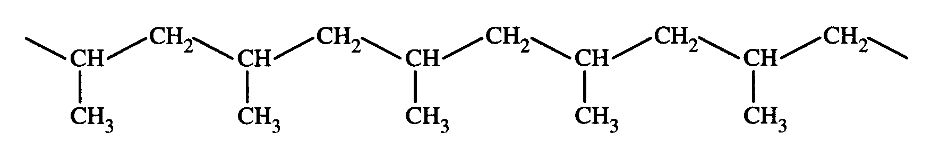

Which of the following is the correct name of ‘X’?
(A) Ethylene
- Propene
- Propane
- 1-methylethene
5 Which of the following reactions is a redox reaction?

- KOH(aq) + HCl(aq) → KCl(aq) + H₂O(l)
- Cu(s) + 2AgNO₃(aq) → Cu(NO₃)₂(aq) + 2Ag(s)
- 2NaCl(aq) + Pb(NO₃)₂(aq) → PbCl₂(s) + 2NaNO₃(aq)
- H₂SO₄(aq) + K₂CO₃(s) → K₂SO₄(aq) + H₂O(l) + CO₂(g)

6 Which of the following lists contains substances which are in order of increasing boiling points?

- ethanol, ethene, ethane
- methanol, ethane, propanol
- propanol, ethanol, methanol
- methane, methanol, methanoic acid

7 The pH of a sulfuric acid solution is measured at 2.0 by a pH meter.

Which of the following alternatives shows the correct concentrations of hydrogen and sulfate ions in this solution?

 | Concentration of hydrogen ions in solution (M) | Concentration of sulfate ions in solution (M)
A | 1.0 x 10⁻¹ | 2.0 x 10⁻¹
B | 1.0x 10⁻² | 2.0 x 10⁻²
C | 1.0 x 10⁻¹ | 5.0 x 10⁻²
D | 1.0 x 10⁻² | 5.0 x 10⁻³

8 Which of following may lead to increased levels of both sulfur dioxide and nitrogen dioxide in the atmosphere?

- Production of photochemical smog
- Lightning strikes during thunderstorms
- Production of radioisotopes at a nuclear reactor
- Production of electricity at a coal-fired power station

9 The table below shows the pH and colour ranges of some common acid-base indicators.

Indicator | low pH colour | pH range | high pH colour
bromothymol blue | Yellow | 6.0-7.6 | blue
phenolphthalein | Colourless | 8.3-10 | pink

A student carries out the following procedure:

- Add a few drops of phenolphthalein to 50mL of 0.1M NH₃ solution.
- Add 50mL of 0.1M HNO₃ (aq) to the NH₃ solution.
- Add a few drops of a bromothymol blue to the mixture formed from steps 1 and 2.

Which of the following is the best prediction of the colour of the mixture at the end of each step of the procedure?

 | Step 1 | Step 2 | Step 3
A | colourless | pink | yellow
B | colourless | pink | green
C | pink | colourless | yellow
D | pink | colourless | blue

10 Which of the following observations can be explained by the Bronsted-Lowry theory of acids but not the Arrhenius theory?

- A solution of hydrochloric acid is a good conductor of electricity.
- Magnesium will displace hydrogen from a solution of sulfuric acid.
- Hydrogen chloride and ammonia gas react to produce solid ammonium chloride.
- When passed through water, carbon dioxide gas decreases the pH of the water.

11 A resident discovered and reported on a number of dead fish floating in their local creek. A team of chemists, including an analytical chemist, an organic chemist, and a biochemist was established to investigate the fish death. What does this example best illustrate?

(A) Collaboration helps chemists solve complex problems.
(B) Validity is improved by increasing the number of people solving a problem.
(C) Reliability is increased when an experiment is done by a group rather than an individual.
(D) Experimental results are more accurate when procedures are undertaken by a team.

12 Which of the following sets of chemical species could have their concentration measured using atomic absorption spectroscopy?

(A) SO₂, SO₃, CO₂, O₃
(B) NH₄⁺, Al³⁺, Cu²⁺, Sr²⁺
(C) Cu²⁺, Hg⁺, Pb²⁺, Pb⁴⁺
(D) SO₄²⁻, CO₃²⁻, Cl⁻, NO₃⁻

13 Which of the following statements describes the context in which the Haber process was developed?

(A) World War I had begun and England’s supplies of nitrogen compounds from Chile had been blockaded by Germany.
(B) World War II had begun and Germany could no longer import nitrogen compounds from Chile.
(C) World War I had begun and Germany’s source of nitrogen compounds had been blockaded by allied forces.
(D) World War II had begun and England’s supplies of nitrogen compounds from Chile had been blockaded by Germany.

14 To measure the percentage of sulfate in a lawn food a student added 30 mL of 2.0M Ba(NO₃)₂ to 0.15 g of lawn food dissolved in 25 mL of water. She obtained 0.24 g of BaSO₄ after the precipitate was washed and dried. What is the percentage of sulfate in the lawn food?

(A) 6.8%
(B) 40%
(C) 62%
(D) 66%

15 The wavelengths of light absorbed by four elements are as follows:

Element | Wavelength (nm)
A | 354.8
B | 551.9
C | 443.7
D | 587.4

Using Atomic Absorption Spectroscopy (AAS), standard solutions of these elements produced the following calibration curves.

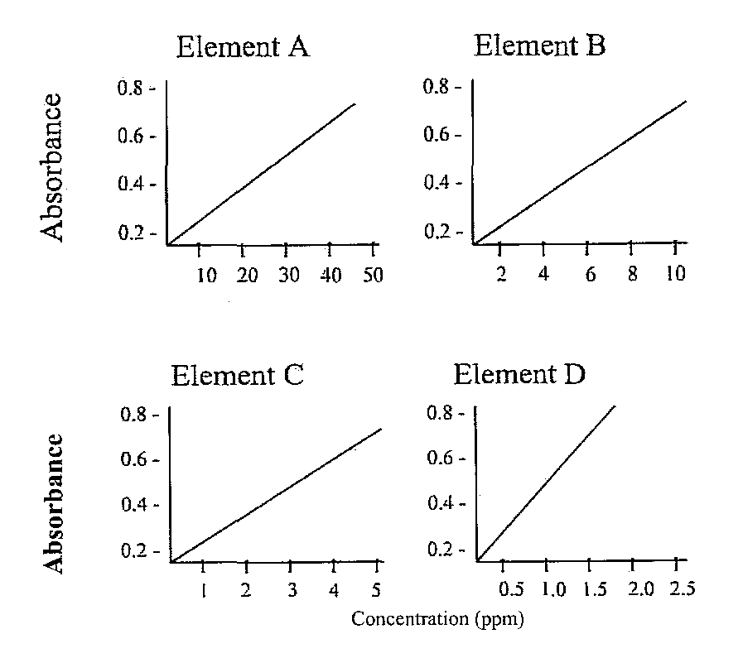
A sample of waste water from a factory was analysed and the following results were obtained:

Wavelength emitted by sample | Absorbance
551.9 | 0.35
443.7 | 0.40
587.4 | 0.65
354.8 | 0.30

The element present with a concentration of 1.5 ppm in the waste water is:
(A) A
(B) B
(C) C
(D) D
Section I (continued)

Part B-60 marks
Attempt Questions 16-28
Allow about 1 hour and 45 minutes for this part.

Answer the questions in the spaces provided.

Show all relevant working in questions involving calculations.

Marks
Question 16 | (4 marks)

Polystyrene is an industrially important polymer.  - Draw the structure of polystyrene showing three (3) repeating units. | 2
- Explain ONE use of this polymer with reference to its properties. | 2
Marks
Question 17 | (7 marks)

A student wanted to compare the molar heat of combustion of 1-pentanol with that of ethanol. To do this, they burned 1.55 g of 1-pentanol to heat 250.0 mL of water from 10.0ºC to 38.0ºC.  - Draw the structural formula of 1-pentanol. | 1

- Using the student's data, calculate the molar heat of combustion of  1-pentanol. | 3

- Identify how you would expect the student's value to compare with the experimental value for ethanol. | 1

- Identify how you would expect the student's value to compare with the theoretical value (eg in the SI Data Book) for 1-pentanol. Explain your answer. | 2
Marks
Question 18 | (6 marks)

During your Chemistry course you have studied a dry cell OR a lead acid cell. You have also compared this cell with one other type of galvanic cell.  Compare the dry cell OR lead acid cell with one other type of galvanic cell, in terms of chemistry, impact on society and impact on the environment. | 6
Marks
Question 19 | (3 marks)

Hypochlorous acid (HOCl) is added to swimming pools as a disinfectant.  (a) Write an equation to show the ionisation of HOCl in water  - Explain what effect a reduction in pH will have on the concentration of HOCl at equilibrium. | 1  2

Question 20 | (3 marks)

A student was provided with two colourless solutions, each in a separate beaker, labelled X and Y. They were informed that one solution was 0.10M hydrochloric acid, the other 0.10M ethanoic acid.  The student performed two tests on the solutions:  Test 1: The pH was determined by inserting a pH probe into each solution.  Test 2: The volume of 0.10M sodium hydroxide solution needed to  reach end-point with the acids was determined with a suitable indicator.  Compare the effectiveness of the two tests in determining the identity of each acid. Justify your answer. | 3
Marks
Question 21 | (5 marks)

The daily recommended intake for Vitamin C (ascorbic acid) is 60 mg.  The label on a brand of orange juice claims the juice contains over half the daily requirement of Vitamin C (ascorbic acid) in every 100 mL of the juice.  The concentration of ascorbic acid in juice can be determined by titration method. A sample of juice is titrated against a standard solution of iodine using starch as an indicator.  The following redox reaction takes place as the iodine is added to the juice sample:  C₆H₈O₆ (aq) + I₂ (aq) → 2I⁻ (aq) + C₆H₆O₆ (aq) + 2H⁺ (aq)  The starch remains colourless as the iodine is added until all of the ascorbic acid present has reacted with the iodine. As soon any excess iodine is present, a blue-black colour is observed, as the starch reacts with the iodine. This is the end-point of the titration.  In an experiment to determine the vitamin C content in the above juice, a 25.0 mL sample of juice was added to a conical flask, along with 5 drops of starch solution. This sample was titrated with 5.00 x 10⁻³ mol/L iodine solution. An average of 9.15 mL of iodine was needed to reach end-point.  (a) Identify the piece of glassware which would be used to accurately deliver 25mL of orange juice into a conical flask and justify the rinsing of this piece of glassware.  - Calculate the mass (in mg) of ascorbic acid present in the 25 mL sample of orange juice. Show your working  - Determine if the claim made on the label of the juice is valid. Show your working. | 2  2  Marks  1
Marks
Question 22 | (4 marks)

Explain the conditions that affect the solubility of carbon dioxide in carbonated beverages. | 4
Marks
Question 23 | (5 marks)

The structural formula of an organic compound (X) is shown in the following diagram.  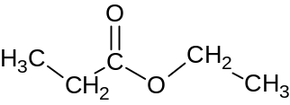  - Name this molecule.  (b) Draw the structural formula and give the IUPAC name for one isomer of this compound.  (c) In an experiment to produce a sample of the organic compound X, a chemist refluxed a suitable reaction mixture for 1 hour. At this point, 5.00 x 10⁻³ moles of H⁺ ions remained in the reaction flask along with compound X. The chemist added excess sodium carbonate solution to remove the unwanted H⁺ ions.  Calculate the volume of carbon dioxide gas which would theoretically be produced from the addition of the sodium carbonate at 25ºC and 100kPa pressure. Show all working. | 1  2  2

Marks
Question 24 | (4 marks)

(a) Oxides of nitrogen (NO_{x}) play a role in the production of photochemical smog. A poisonous gas present in this smog is an allotrope of oxygen.  Identify this gas.  - Describe another environmental issue associated with increased levels of NO_{x} in the atmosphere. | 1  3

Question 25 | (4 marks)

- Write a balanced chemical equation for the reaction occurring in the Haber process. |  |  | 1
- Explain why the rate, but not the yield, is increased when higher temperatures are used in the Haber process. |  |  | 3
Question 26 | (5 marks) | Marks

A chemical mixture of ionic salts is known to contain two of the following cations:  Ca²⁺; Ba²⁺; Cu²⁺; Pb²⁺; Fe²⁺  A student planned and followed the procedure, shown in the following flowchart, and identified the two unknown cations in a mixture.  mixture of two unknown cations  2M HCl (aq) added. A white solid formed.  HCl was added until precipitation ceased.  0.1 M H₂SO₄(aq) added to the same sample.  A white precipitate formed which gave a  lime-coloured flame in a flame test.  - Identify the cation responsible for the white precipitate formed upon addition of HCl. | 1
(b) Write a net ionic equation for the reaction which produced the white precipitate with H₂SO_{4.} | 1
- Justify the procedure the student followed to identify these two cations. | 3
Marks
Question 27 | (6 marks)

When scientists first developed chlorofluorocarbons (CFCs) for use in domestic and industrial applications, they were considered the ideal species. However, their use has resulted in significant environmental damage due to the destruction of ozone molecules in the stratosphere. Fortunately, scientists have been instrumental in recognising the problems and devising solutions to them. This includes the development of alternative chemicals to replace CFCs.  - Draw a Lewis electron dot diagram of ozone, and label the electrons in the coordinate covalent bond. | 2
- Identify alternative chemicals used to replace CFCs and evaluate the effectiveness of their use as a replacement for CFCs. | 4

Marks
Question 28 | (4 marks)

A student carried out various water quality tests on samples of water from five different locations, labelled A - E. Their results are summarised in the table below.  - Identify the site (A to E) which may have been located next to farmland. Justify your answer.  - Identify which sample would be classified as the “hardest” and explain one impact that this would have on people using this water. | 2  2
   | A | B | C | D | E
  Turbidity (NTU) | 0.9 | 15.5 | 2.1 | 10.4 | 50.2
  pH | 7.4 | 8.6 | 7.0 | 7.2 | 6.9
  DO (ppm) | 9.2 | 6.0 | 6.8 | 6.5 | 6.8
  Phosphate (ppm) | 0.03 | 0.30 | 0.03 | 0.01 | 0.05
  Ca²⁺ (ppm) | 32 | 21 | 87 | 20 | 18

Section II
25 marks
Allow about 45 minutes for this section.

Answer in a writing booklet. Extra booklets are available.

Show all relevant working in questions involving calculations.

Marks
Question 29 ---Shipwrecks, Corrosion and Conservation (25 marks)

(a) | (i) | Wayne no longer collects sea shells to analyse them for calcium carbonate. Instead, he spends all his spare time using his new metal detector in search of buried treasure. He hasn’t had much luck in finding any treasure, but he did find a rusted metal pipe. He was so proud of his discovery, he made a sketch of the pipe to show his class.  Fe  cathodic  area  anodic area  e⁻  Fe²⁺  OH⁻  rust observed  Identify the oxidation state of iron in the rust observed on the inside of the pipe. | 1
 | (ii) | Wayne told his class that all underground pipes should be protected from corrosion. Explain how an underground steel pipe could be protected from corrosion using TWO suitable methods. | 3
 | (iii) | In the above diagram, oxygen is reduced in the presence of water. If the pipe was exposed to acidic conditions, oxygen may be reduced in the presence of H⁺ ions.  Compare the Eº produced by the Fe/Fe ²⁺reaction coupled with the reduction of oxygen under these two different conditions. Include equations and calculations in your answer.  Question 29 continues on page 24 | 3

Marks
Question 29 (continued)

(b) | (i) | During your practical work, you performed a first hand investigation to observe the effect of the concentration of a solution on the rate of its electrolysis.  Outline the method you followed, and describe your observations, for this investigation. | 3
 | (ii) | Account for any differences in the reaction products you observed during electrolysis when the solution was dilute and when it was concentrated. Include relevant equations with your answer. | 3

(c) | (i) | Assess factors that affect the extent of corrosion of metal structures and artifacts exposed to an aqueous environment as a result of a shipwreck. | 7

(d) | (i) | In the late 1700s, Galvani observed muscle contractions in a frog’s leg when its spinal cord was connected by copper hooks to an iron railing.  Contrast the inferences made by Galvani and Volta to explain the cause of these contractions. | 2
 | (ii) | Explain the significance of Volta’s work in the area of electron-transfer reactions. | 3

